Mulberry Park Management Company Ltd
2024 AGM – (held on Sat 1 Feb 2025)
Meeting Venue:- NCD – Student Union
Start Time – 10:00am…Duration: 1hr
Meeting notes taken by Alan Perkins and Wendy Roughley

Minutes

- Welcome & Introductions
MP Directors:- Angie Perkins+Barry Roughley
CWS:- Karolina Stuliglowa …representing our Professional Management Consultants

The Directors welcomed everyone to the meeting.

- Apologies
No apologies were received for non-attendees.
The Directors gave apologies for the late convening of the 2024 AGM which should have been held in Dec 2024. This was due mainly to a combination of health issues, work pressures and family commitments around that time.
Adding to this, we found out late in the year that our appointed infrastructure maintenance contractor sadly went into administration earlier in the year which explained why our attempts to contact them throughout the year went unanswered and why some planned routine maintenance works around the estate was not undertaken in 2024.

- Attendance
Nine Mulberry Park estate residents (plus two MP Directors and one CWS representative) attended the 2024 AGM this year, who were thanked for their turnout in representing the thoughts and interests of those living on the estate.
In addition 23 proxy votes were also received by Craven Wildsmith on behalf of absent shareholders.

- Review of last AGM Minutes Dec 2023
Some attendees claimed they did not receive the 2023AGM Minutes sent out around a year ago*.
MP Directors stated that all estate resident shareholders will have received a copy of the Dec 2023 AGM Minutes and the accompanying Information Sheet…they were hand delivered (and duly registered) to all resident shareholders on the estate and also mailed out to non-resident shareholders ie, Property Landlords.
The headline contents of the 2023 AGM was duly noted and after discussion the minutes were accepted as a true record of the meeting.

Several attendees thanked the Directors for their services…this was much appreciated.

*Note:- Residents were politely asked always to retain the meeting Minutes+Information Sheet and bring them for reference to the next AGM as further copies are not provided to save on cost.

AGM 2024 (1st Feb 2025)

Directors Report:-

- Financial Accounts Report (2023)
AP outlined the MP account details and expenditures for 2023 as prepared by our Accountants-Thimbleby and Co… the full accounts were submitted to Company’s House and copies are available to shareholders upon request.
Summary:-
- Annual income approx £37k.
- Annual fixed charges ≈approx £17k (CWS Professional Mgt Fees, insurance, cyclical grounds maintenance, energy, administration, legal, accounting, sundry expenses).
- Annual remaining budget for estate maintenance approx £10k…roads, street lighting, drainage, signage, emergency infrastructure maintenance and ancillary works, etc.
- Current bank balance approx £42k.
- Debtors…outstanding maintenance fees unpaid total approx £17k (this includes the 1st half year payments of 2025)…these will be chased up by CWS.

- Maintenance Fees for 2025:-
The Annual Service Charge for 2025 will remain at £220 for the coming year as we were somewhat restricted in undertaking much of our routine maintenance works last year due to our highways contractor going into administration.

Reminder: (as minuted last year)…
Service charges to be paid in 2no equal instalments of £110 (invoiced on 1st Jan 2025 and 1st July 2025)….bills to be hand delivered to estate resident property owners and mailed out to non-resident property owners, ie Landlords.

Payments may be accepted in various ways:
- 2no lump sum instalments in Jan and July annually (preferably by bank transfer or by cheque via CWS)…payments by phone to CWS must be via a Debit Card transaction.
- Monthly payments by standing order to be paid by 31st monthly (set up via CWS).
CWS Bank Details:-
Bank: Santander
A/C Name: Craven Wildsmith Property Management LLP
A/C Type: Select – Business Account (when prompted)
Sort Code: 09-02-22
A/C Number: 10668029
Reference: your surname and first line of your address

Outstanding Payments of annual service fees are being chased up in various ways reflective of the amounts owed. Property owners are reminded that any outstanding debts will be subject to interest charges and also professional, administrative and possible legal charges.
A payment plan may be agreed and set up via CWS to recover the overdue service fees.

Voting Rights:- (for information)
The MP ‘Articles of Association’ ref Clause 57 states that a member (shareholder) is not eligible to vote at a meeting in person or by proxy unless all monies payable by them in respect of the share has been paid. The Directors have slightly relaxed this position such that voting in the AGM will be permitted providing no more than 6 months annual service fees are outstanding.

We further qualified this position in the 2023 AGM Minutes, stating that if any outstanding payments are being recovered through an agreed payment plan via CWS, and providing this payment plan is being adhered to, then the shareholder will be deemed to be in ‘good financial standing’ and therefore able to vote at the AGM.

- The 2024 Annual Safety and Service Inspection:- was undertaken in December 2024 and the estate was found to be in reasonably good order at this time with no emergency or major works required … (with the exception of the OTA grass verge frontage erosion due to vehicle parking and over-ride… the verge maintenance proposal, options, costs and affordability was further discussed and reviewed later in the meeting).

During the annual inspection it was observed that various building materials and other items had been deposited on MP land and some items had been there for a considerable time. There was also some excessive erosion of the grassed areas observed due to resident vehicle parking.
A letter was sent out to residents earlier in the year (2024) requesting them to remove such items and to make good the land. Follow-up letters will be sent out to the respective home owners asking for this to be undertaken and if still not done then MP will undertake this work and the home owners will be billed accordingly.

Vote:- Shareholders agreed that this was a reasonable position to take.

- Works undertaken in 2024:-
Blue LED street lights…Fowlers replaced the defective street lights around the estate costing around £5k.

Provided planting areas at the OTA junctions with Poplar and Walnut.
Note:- some plants have failed…AP will speak with the specialist plant providers and seek other more suitable ones for these locations. Need time to become established and need to be watchful of damage from passing school children.

Annual grounds maintenance works.

Various routine maintenance works were identified…these have been carried forward into 2025 due to the status of our previous maintenance contractor.

- Works previously programmed for 2024 to be picked up with works in 2025:-
Reported:- 2 more blue LED street lights have been reported…one outside the flats on Hazel Ave and the other on the estate (to be notified) …Fowlers to be asked to replace.

Estate - Overgrown bushes and grass edges are to be trimmed-back along all footways to reclaim their full width. In particular pruning of the tree at the corner of Poplar and Hazel in order to clear the BT lines.
Reported – Gardener sometimes running his vehicle and parking over footpaths fronting the houses on OTA…AP will speak with him.

Estate - Gullies will be checked for blockages and breakages and maintained as necessary.
Reported:- Sunken gully on Hazel Ave s/o 16A Walnut… lift to level upon the engagement of a new contractor (currently being sought).

Estate - Street name plates and signs…several are missing or in need of replacement around the estate.

Poplar Way fronting nos 1 to 4 - resurfacing of the parking areas approx 30m x 3m.

Hazel Ave o/s 1-3 – lighting column straightening and barrier protection.

Lilac Grove jct Hazel Ave – following the land sale s/o 8 Lilac Grove, we shall be using the sale funds to seek a price to extend the footway from 8 Lilac Gr around the corner to a point opposite the existing footway on Hazel Ave in order to provide for safe pedestrian passage and continuity across the road to the existing footway on Hazel.

Oak Tree Ave – seeking prices for the replacement of the old decayed timber bollards with composite bollards to help mitigate the school parking issues along the entire length of the road.

Oak Tree Ave:- Verge Maintenance Scheme:-

Refer to full review discussion and maintenance options reported at AGM 2023 Minutes.
The estate frontage status of OTA was again discussed and reviewed, with attending residents agreeing with the ‘special’ status of this road frontage in reflecting the environment of the estate and the need for maintenance of the grassed verge.
It was acknowledged that the road width of OTA is significantly narrower than other roads on the estate and it does not accommodate two-way passing traffic (unlike the other roads on the estate), therefore a widening scheme of some description is required reflective of the ongoing school trafficking problem which cannot be readily resolved despite efforts over the years to do so.

Approved Maintenance Option:
It was agreed that a verge structural maintenance scheme was required in order to accept occasional two-way passing traffic along OTA and to mitigate the extensive damage exhibited.

Several road/verge maintenance options have been considered and the favoured solution is to retain the open aesthetics of the grassed frontage by effectively widening the trafficked surface by adopting a method to strengthen the eroded verge margin with the placement of a linear geo-grid approx 1.5 metres wide. The geo-grid would be founded on a permeable structural foundation (capable of carrying occasional vehicular traffic) thereby allowing for drainage, and it shall be retained with concrete edging. Turf would then be rolled (punched) into the soil filled cells of the geo-grid to retain the appearance of the grass verge and to provide an immediate trafficable platform on which vehicles may pass with due care without further damage to the verge. Vehicles would initially need to traffic over this new surface carefully whilst the roots of the turf take hold. In addition, the adjacent grassed area may in places need to be graded out and made good to remove any acute level differences.

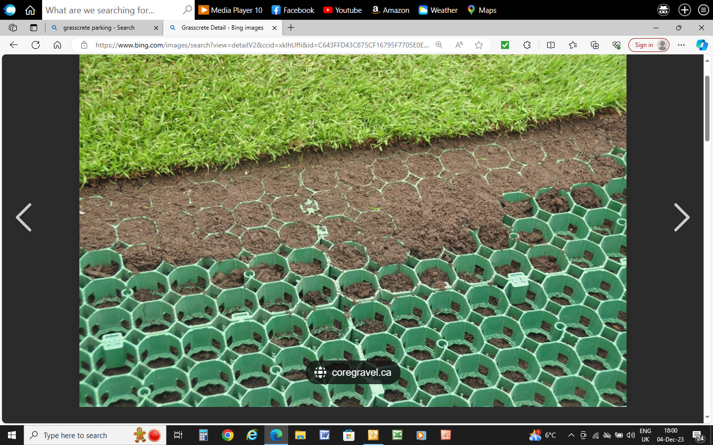

It was agreed that a trial scheme would firstly be undertaken in 2025 and a suitable frontage location would be identified for the trail of a length of say 50metres (approx 1/3rd of the whole length), reflective of cost and affordability, in order to test the viability and success of the proposed solution. If proved successful, the maintenance solution would then be extended to the full length of OTA on a phased basis over say a period of 2-3 years reflective of available annual funding provisions.

Competitive contractor quotes for these extensive works will be sought.

Vote:- Attendees at the meeting were invited to comment on the proposal and offer any further thoughts or alternative maintenance solutions. No alternative solutions were forthcoming therefore the above verge maintenance proposal was accepted.

Appointment of Directors
AP+BR will remain as MP Directors for a 3 year period until the next AGM in Nov/Dec 2025 as voted and agreed at the 2022 AGM.

Note:- As residents are aware…the appointment of a MP Director is a voluntary position for which no direct salary payment is made, their time is given freely for the effective governance of the estate. However if suitable volunteer Directors are not appointed then the administration and management of the Mulberry Park Management Company Ltd would fall to an appointed Professional Management Company and the annual estate management fees would likely increase significantly.

With this in mind, should anyone wish to be considered for a MP Estate Directorship during or after 2025, they should apply for a nomination form to be sent out to them well in advance of the AGM in Dec2025.

Directors do not need to be residents or shareholders on the estate but they do need to demonstrate they have something positive to offer with regards to the management, administration and ongoing business of estate and/or have specific skills/knowledge to support and assist in such management and administration processes. Qualifications are not required to be a Director however common sense, trust and commitment are most welcomed for this role.

- A.O.B
Reported:- Walnut Ave, some residents are still parking their vehicles over the footways on both sides. This is to be monitored and more letters will be sent out as necessary.

Reported:- Willow fronting new houses…small area of road surface erosion…to be looked at in conjunction with resurfacing parking bay on Poplar.

Reported:- CWS (PW) not responding/timely to emails on occasions…Directors to bring this to CWS attention.

Reminder:- please submit any discussion items by email to the MP Directors for their investigation and consideration before the date of the AGM.

Reminder:- please report any maintenance matters in writing to the MP Directors or CWS as they arise throughout the year for our investigation and maintenance consideration…not just before or during an AGM.

Note:- Upon receipt of the 2024 AGM Minutes, should you have any comments with the completeness or correctness of the minutes, please contact the MP Directors asap to discuss.

- Close of Meeting…10:55am

